(Type your name)

I completed ____ of the 30 activities.

I did not complete the following activities:

CDS 431: Beginning Clinical Methods

In-Class Activities

This packet includes activities that we will do in-class. Some activities may be completed outside of class. You will post this finished packet on Canvas for grading.

Type your responses using your favorite easy-to-read colored font (not black). This will help you know how many activities you have completed at the end of the term.

You may print out this packet, handwrite answers, and scan the final document to post on Canvas.

At the end of the term, enter the total number of activities that you completed at the top of this document. Activities 5 and 21 are reading only. Activity 24 will be submitted through Canvas for a separate grade. One point is earned for completing the remainder of the activities. Total number of possible points for this packet is **27**.

**Case Study: In-Class Activities**

**Activity #1: Case Review (Complete Individually)**

|  |  |
| --- | --- |
| **Client’s Name:** | **Client’s Age:** 5 years old |
| **Client’s Sex:** | **Assessment Date:** 3/14/14 |
|  | |

**Referral source:**

**Reason(s) for referral:**

**Birth History**:

**Developmental History**:

**Current living situation**:

**Previous Testing (include speech/language testing, other developmental/educational testing, hearing/vision testing):**

**Hearing Results:**

(complete table with developmental assessment results on next page)

**Assessment Summary**

Assessment, Evaluation and Programming System for Birth to Three Years (AEPS)

Gesell?? Revised Gesell Developmental Inventories / Gesell Developmental Schedules (no longer used)

Preschool Language Scale – 4th Edition

The Battelle Developmental Inventory – 2nd Edition

|  |  |  |  |  |  |  |  |
| --- | --- | --- | --- | --- | --- | --- | --- |
| **Domains** | **20 months** | | **27 months** | | **3 years** | | **5-year IFSP**  **Present Levels & Goals** |
|  | **AEPS: to 3**  % items mastered | **Gesell**  Standard score | **AEPS: to 3**  % items mastered | **PLS-4**  Standard Score | **AEPS: 3-6**  % items mastered | **BDI-2**  Standard Score |  |
| **Fine Motor** |  |  |  |  |  |  |  |
| **Gross Motor** |  |  |  |  |  |  |  |
| **Adaptive** |  |  |  |  |  |  |  |
| **Cognitive** |  |  |  |  |  |  |  |
| **Communication** |  |  |  |  |  |  |  |
| **Receptive** |  |  |  |  |  |  |  |
| **Expressive** |  |  |  |  |  |  |  |
| **Social** |  |  |  |  |  |  |  |
| **Intelligibility/MLU** |  |  |  |  |  |  |  |

**Does the child have an educational plan (e.g. IEP or IFSP)? If yes, list the date of the most recent plan and the agency providing services.**

**List all therapies/ educational services the child is receiving from early intervention or other agencies/schools (include names of providers and therapy frequency**):

|  |  |  |  |  |
| --- | --- | --- | --- | --- |
| **Type of Service**  **Agency/ School where child receives services** | **When services were started/ terminated** | **Currently receiving services? (yes/no)** | **Therapist’s/ Teacher’s name** | **Frequency of service (# of days/ # of hours)** |
|  |  |  |  |  |
|  |  |  |  |  |
|  |  |  |  |  |
|  |  |  |  |  |

**IFSP Goals**

**In what areas does the child have IFSP goals?**

**List Goals/Objectives related to communication skills.**

**Description of Current Speech/Language Skills:**

**Other Important Information you want to remember**

**Activity #2: Specify reason(s) for assessment****(Check all that apply)**:

|  |  |
| --- | --- |
| **Diagnostic:**  __Make a (new) diagnosis  __Determine whether a diagnosis is still present  __Determine (ongoing) eligibility/need for service  __ Other: | **Programmatic:**  __Establish (new) goals  __Determine (new) intervention approach  __Establish a (new) baseline of performance  __Document progress on current goals  __Document progress in areas currently not targeted  __Other: |

**Activity #3: Speech Sound Disorder Review (Small Group Discussion)**

* *Define Speech Sound Disorder (SSD)*
* *Contrast the difference between Phonological Disorders and Articulation Disorders*
* *How do SSDs relate to Reading Disorders?*
* *What’s the relationship between SSDs and Hearing?*
* *List informal/formal assessment methods commonly used with children with SSD?*
* *Briefly describe the following approaches:*
  + *Minimal pair*
  + *Cycles*
  + *Metaphonological*

**Activity #4: Watch a language sample and form your initial clinical impressions**

Matthew’s assessment started with a language sample. Before watching the video, read through the following questions and be prepared to answer them either while watching the video or immediately afterwards.

*How intelligible is Matthew’s speech (i.e., how much of his speech did you understand)? (don’t take data, just your impression)*

*Were there any error patterns you identified while listening to the sample (no need to take data, just list any that were obvious to you)?*

*Based on your clinical impression (no data) do you think his* ***speech*** *skills are age-appropriate? Explain why.*

*Based on your clinical impression (no data) do you think his* ***language*** *skills are age-appropriate? Explain why.*

*Based on your clinical impression, did you observe anything different about his oral motor skills?*

*What strategies did the clinician use to gather this language sample?*

*What do you think was the purpose of doing this language sample before the rest of the testing was done?*

**Activity #5: Norm-referenced Test: Diagnostic Assessment of Articulation and Phonology (DEAP)**

Read through the marked protocol as you watch the DEAP and then discuss the scores as a group.

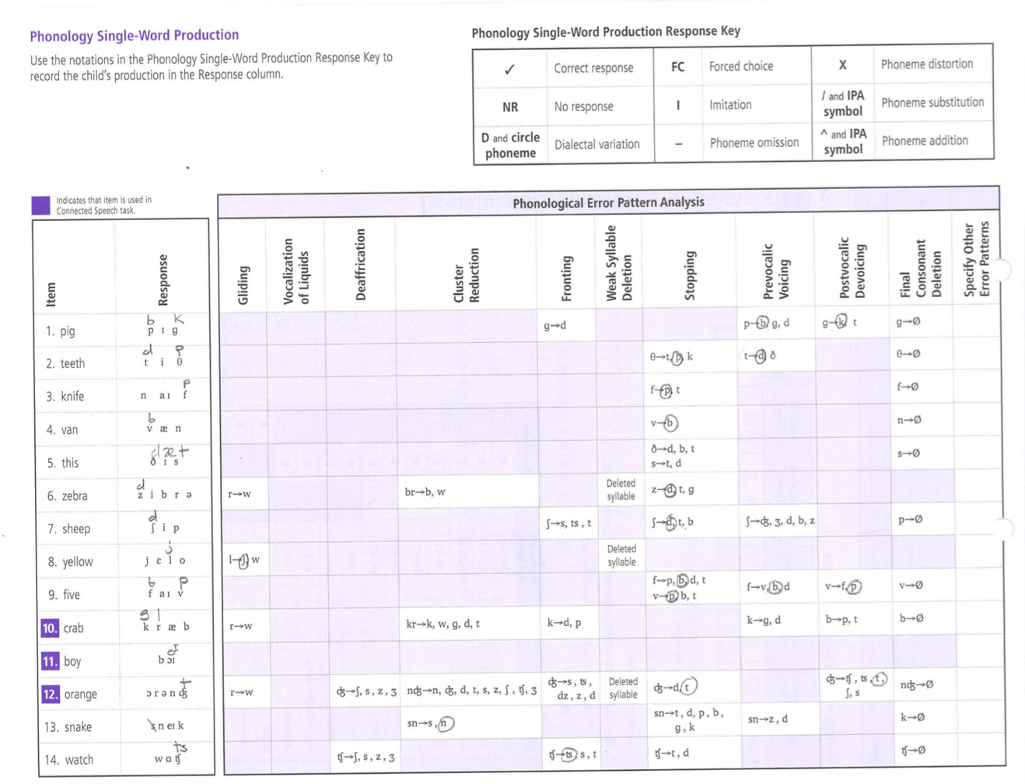

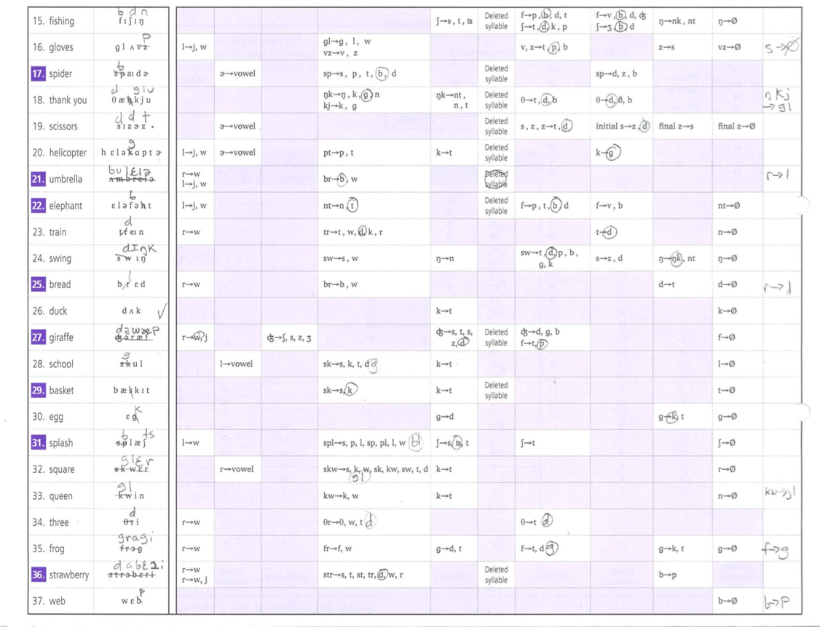

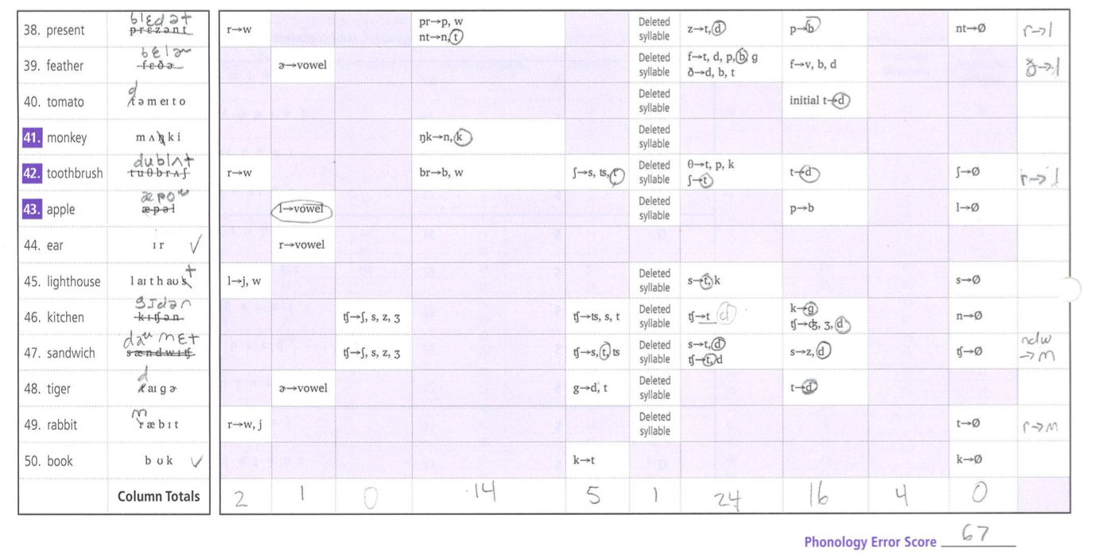

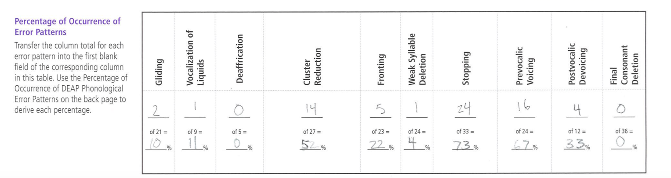

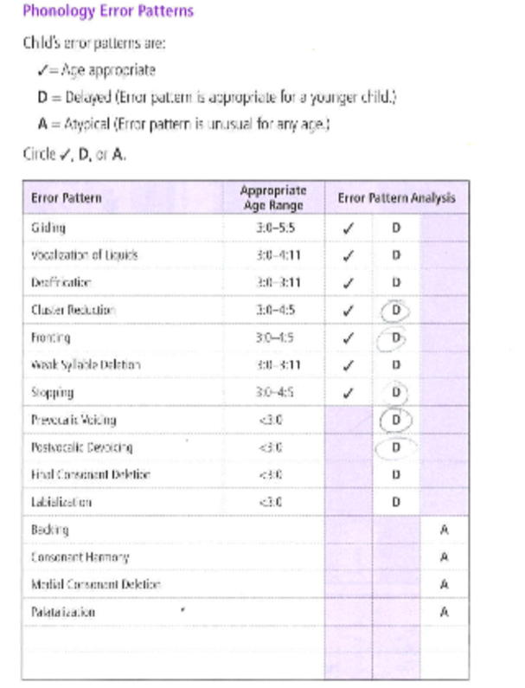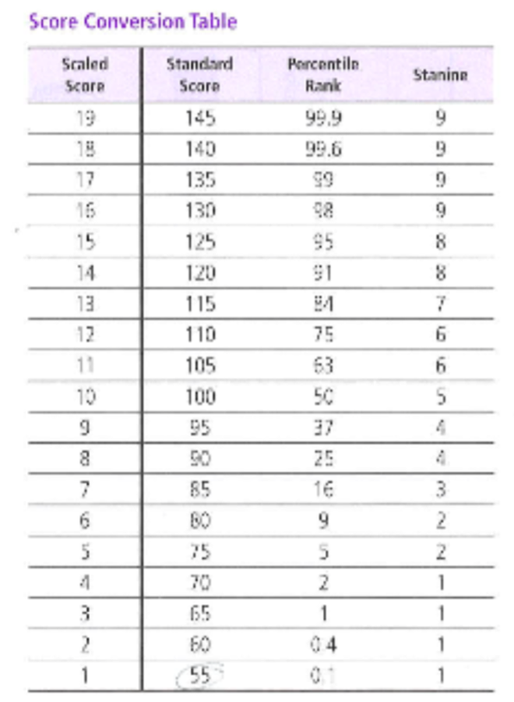

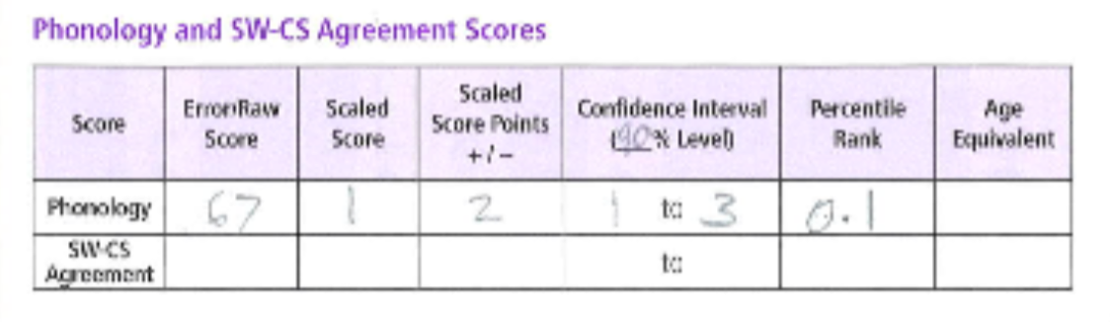

**Activity #6: Norm-Reference Test: Clinical Evaluation of Language Fundamentals- Preschool 2 (CELF-P2)**

Review the CELF-P2 scoring sheet as you watch the video. Then score using the manual.

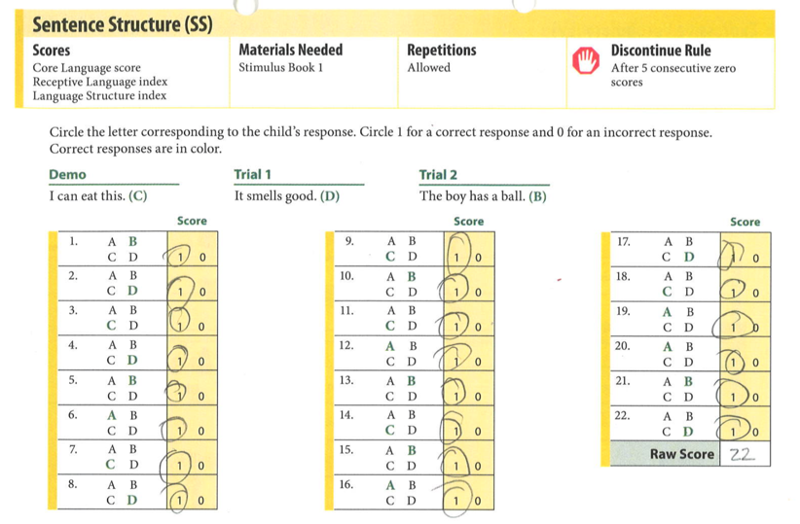

CELF-P Scoring table (Matthew’s age = 5 years, 1 month)

|  |  |  |  |  |  |  |
| --- | --- | --- | --- | --- | --- | --- |
| Subtest | Raw Score | Scaled Score | Scaled Score Points | Confidence Interval (90% level) | Percentile Rank | Percentile Rank Confidence Interval |
| Sentence Structure | 22 |  |  |  |  |  |

**Activity #7. Informal Measure: Pre-Vocalic Voicing Probe**

For each target word, we are only interested in the first sound. If the sound is voiced, in the 1st or 3rd columns cross out the first letter and put what Matthew said above it. In the 2nd or 4th columns, indicate that it was incorrect (0 points). If the sound is said correctly (unvoiced), leave the 1st or 3rd columns as it is and score it as correct (1 point) in the 2nd or 4th columns. The first two are scored for you. (note: sometimes the sounds are very similar, if you can’t decide, give him the point).

|  |  |  |  |
| --- | --- | --- | --- |
| **Target word** | **Score (1/0)** | **Target word** | **Score (1/0)** |
| b  **~~p~~**ear | 0 | **p**et |  |
| d  **~~t~~**en | 0 | **t**ea |  |
| can |  | **c**oal |  |
| **p**op |  | **p**eak |  |
| **t**ag |  | **t**ot |  |
| **c**ap |  | **c**old |  |
| **p**eas |  | **p**ath |  |
| **t**op |  | **t**own |  |
| **c**url |  | **c**ard |  |
| **p**ug |  | **p**ush |  |
| **t**ip |  | **t**wo |  |
| **c**oat |  | **c**at |  |

_____ total correct / 24 total = ________ % correct

**Activity #8. Informal Measure: Final Cluster Stop + Fricative Probe**

In this probe we were interested in determining whether Matthew could produce a stop + a fricative at the end of the word. For each target word, we are only interested in the final two sounds (stop+fricative).

* If Matthew makes any stop consonant + a fricative count it as correct (even if it is the wrong stop or fricative) and leave the 1st or 3rd columns as is and score it as correct (1 point) in the 2nd or 4th columns.
* If he doesn’t say a stop + fricative- in the 1st or 3rd columns cross out the incorrect letter and put what Matthew said above it OR just cross out the letter if he deletes that sound. In the 2nd or 4th columns, indicate that it was incorrect (0 points).

The first two are scored for you. (note: if he says it correctly at any time count it as correct even if he says it incorrectly another time)

|  |  |  |  |
| --- | --- | --- | --- |
| **Target word** | **Score (1/0)** | **Target word** | **Score (1/0)** |
| Nuts /t~~s~~/ | 0 | Lights /ts/ |  |
| t  Hops /p~~s~~/ | 0 | Pups /ps/ |  |
| Ducks /ks/ |  | Hooks /ks/ |  |
| Figs /gz/ |  | Bags /gz/ |  |
| Rides /dz/ |  | Hides /dz/ |  |
| Cuts /ts/ |  | Boots /ts/ |  |
| Lips /ps/ |  | Leaps /ps/ |  |
| Fox /ks/ |  | Ticks /ks/ |  |
| Dogs /gz/ |  | Hogs /gz/ |  |
| Reads /dz/ |  | Beds /dz/ |  |
| Bites /ts/ |  | Cats /ts/ |  |
| Wipes /ps/ |  | Tops /ps/ |  |
| Mix /ks/ |  | Hikes /ks/ |  |
| Tags /gz/ |  | Digs /gz/ |  |
| Loads /dz/ |  | Leads /dz/ |  |
| Tights /ts/ |  | Bats /ts/ |  |
| Cups /ps/ |  | Peeps /ps/ |  |
| Pokes /ks/ |  | Locks /ks/ |  |
| Jogs /gz/ |  | Logs /gz/ |  |
| Heads /dz/ |  | Weeds /dz/ |  |

_____ total correct / 40 total = ________ % correct

**Activity #9. Informal Measures: Phoneme awareness probes**

Watch the Phonological Awareness Probes. The results are as follows:

Letter-Sound Identification (identifying the sounds that letters make, such as the letter “c” makes the /k/ sound)

4/9 correct

s, p, t, k correct

m, n, b, f, d incorrect

Initial Sound Identification (identifying the first sound in a word, such as /k/ at the beginning of “cat”),

4/8 correct, but incorrect were also error sound patterns. Matthew appeared to be able to identify the first sound, just said it incorrectly.

Blending (putting the sounds of a word together to identify the word, such as /k/ + /a/ + /t/ = “cat”).

Matthew could not learn the blending task during the practice items so neither probe was administered.

Answer the following questions:

***What do you think about Matthew’s phonological awareness skills?***

***Would you want to improve these skills, why or why not?***

**Activity #10: Clinical Question Analysis**

Complete the table, making sure to add all required information into column 2 and then complete column 3 (short direct answer)

|  |  |  |
| --- | --- | --- |
| **Clinical question** | **Evidence gathered during session** | **Answer to clinical question/ further evidence needed** |
| How significant is Matthew’s speech sound disorder? | DEAP standard score and percentile: |  |
| How can we describe his speech sound disorder?   * What phonological patterns does he have in error? (DEAP) * How intelligible is his speech? (clinical impression) | DEAP (list significant error patterns):  Intelligibility (clinical impression): |  |
| What kindergarten phonological awareness skills does he have?   * Does he know his letter sounds? (letter sound probe) * Can he identify the first sound in words? (initial sound identification probe) * Can he blend/segment words? (blending and segmenting probes) | Letter sound Probe:  4/9 correct  s, p, t, k correct  m, n, b, s, d incorrect  Initial Sound ID Probe:  4/8 correct, but incorrect were also error sound patterns. Matthew appeared to be able to identify the first sound, just said it incorrectly.  Blending/Segmenting Probes:  Matthew could not learn the blending task during the practice items so neither probe was administered. |  |
| What other factors may be contributing to his speech sound disorder?   * Hearing status? (parent interview) * Oral motor skills? (clinical impression) * Overall Expressive Language Disorder (clinical impression) * Comprehension skills (CELF-P2) | Hearing Information (interview)- Matthew failed a screening during a recent well-check visit at the doctor’s office. His pediatrician has made a referral to an audiologist for a full evaluation.  Oral Motor Skills (clinical impression):  Expressive language skills (clinical impression)  CELF-P2: |  |
| What is the best treatment plan?   * What error patterns should be targeted first and what is Matthew’s baseline on those error patterns? (speech sound probes) * What does the research say is the best approach for treating Matthew’s SSD? * What are the family’s preferences concerning therapy? (interview) | Speech Sound Probes:  r- cluster probe: 0/35 correct (0%)  Stopping probe: 0/28 correct (0%)  Initial s+stop and s+nasal probe: 0/35 correct (0%)  Pre-vocalic voicing probe:  Final cluster stop + fricative probe:  Research: Will be answered by Assignment #3  Family Preferences (interview): Matthew’s parents stated that they would like Matthew to have weekly, 1-on-1 therapy in the HEDCO clinic. They were excited about the idea of being involved in the therapy and said they had the time and interest to daily home activities with him. | Leave this part blank: we will address this in the future activities. |

**Activity #11:** Diagnosis and Therapy Needs

Review your answers to the clinical assessment questions and answer the following questions.

*What is Matthew’s communication diagnosis? Is it primary or secondary?*

*Do you think Matthew needs additional therapy (above what he is receiving at Early Childhood CARES)? Why/ Why not?*

*What skills would you, as Matthew’s SLP, want to target in therapy? What would be the goals of your therapy (you don’t need to write them in goal format- we’ll do that next week)*

*What else do you want to keep in mind as you plan Matthew’s treatment?*

**Activity #12: Read the Assessment Report**

*Did anything about Matthew’s assessment report surprise you? Any questions?*

**Activity #13: Framing PICO Questions**

Write PICO questions for the following:

|  |  |  |  |
| --- | --- | --- | --- |
| **Population** | **Intervention** | **Comparison** | **Outcome** |
| Stroke patients | Early initiation of aphasia therapy | Aphasia treatment after initial/spontaneous recovery time | Higher functional communication abilities |
| Toddlers with expressive language delay | Parent training to administer treatment at home | Direct treatment by therapist | Faster acquisition of functional vocabulary |
| Adolescents with TBI | Cognitive rehab | No cognitive rehab | Return to school/work faster |

1. Are patients with aphasia who received SLP services shortly after their stroke more or less likely to achieve functional communication abilities than stroke patients who received such treatments later?

2.

3.

**Activity #14: Framing and Writing Possible PICO Questions for Matthew’s Research into the Best Intervention for Matthew**

|  |  |  |  |
| --- | --- | --- | --- |
| **Population** | **Intervention** | **Comparison** | **Outcome** |
|  |  |  |  |
|  |  |  |  |
|  |  |  |  |

1.

2.

3.

**Activity #15: Choosing a Treatment Approach for Matthew**

*In small groups, discuss the pros/cons of each treatment approach for Matthew.*

|  |  |  |
| --- | --- | --- |
| **Treatment approach** | **Pros** | **Cons** |
| Cycles |  |  |
| Minimal Pairs |  |  |
| Metaphonological |  |  |

*Is there one of these treatment approaches that meets all of Matthew’s therapy needs? Explain.*

*If you wanted to make a “hybrid treatment approach”--- what components of the three treatment approaches would you want to use in the hybrid approach?*

**Activity #16: Evaluating Matthew’s Goals**

Read Matthew’s LTGs and STOs and answer the following questions:

Long-term goal (LTG) 1: Matthew will correctly produce the sounds /s/ and /z/ in the final position of words ending in two consonants (such as “bats” and “dogs”), with at least 80% correct on a single-word probe containing 40 words.

Short-term objective (STO) 1.1: Matthew will imitate the sounds /s/ and /z/ in the final position of words ending in two consonants, with 80% accuracy (given at least 10 opportunities).

STO 1.2: When provided with a verbal prompt (such as “add the /s/ sound”), Matthew will include the final sounds /s/ and /z/ when producing words ending with two consonant sounds, with 80% accuracy (given at least 10 opportunities).

STO 1.3: In structured tasks in the clinic and at home, Matthew will include the final sounds /s/ and /z/ when producing words ending with two consonant sounds, with 80% accuracy (given at least 10 opportunities).

LTG 2: Matthew will correctly produce voiceless consonants (such as /t/, /p/, and /f/) in the initial position of words (such as “pig”, “top” or “fish”) with at least 80% correct on a single-word probe containing 24 words.

STO 2.1: Matthew will correctly imitate voiceless consonants in the initial position of words, with 80% accuracy (given at least 10 opportunities).

STO 2.2: When provided with a verbal prompt (such as “turn off your voice”), Matthew will produce voiceless consonants in the initial position of words, with 80% accuracy (given at least 10 opportunities).

STO 2.3: In structured tasks in the clinic and at home, Matthew will correctly say voiceless consonants in the initial position of words with 80% accuracy (given at least 10 opportunities).

LTG 3: When provided with a segmented word (such as “c-a-t-s”), Matthew will blend the word correctly (“cats”) with at least 80% correct on a probe containing 12 words.

STO 3.1: When provided with a segmented word, Matthew will point to the correct picture card (out of a field of two), with 80% accuracy (given at least 10 opportunities).

STO 3.2: When provided with a segmented word, Matthew will point to the correct picture card (out of a field of two) and imitate the blended word, with 80% accuracy (given at least 10 opportunities).

STO 3.3: When provided with a segmented word, Matthew will point to the correct picture card (out of a field of two) and independently say the blended word, with 80% accuracy (given at least 10 opportunities).

*Evaluate each of Matthew’s goals according to SMART criteria. Indicate whether it meets the following criteria “yes” or “no”. If no, then what could be done to make the goal better?*

|  |  |  |  |
| --- | --- | --- | --- |
| SMART Criteria | Goal 1 | Goal 2 | Goal 3 |
| Specific |  |  |  |
| Measurable |  |  |  |
| Attainable  (action word) |  |  |  |
| Relevant |  |  |  |
| Time frame |  |  |  |

**Activity #17: Reviewing Matthew’s Treatment Plan**

Review Matthew’s treatment plan, add possible target words for weeks 4 & 5, and then answer the following questions:

Matthew’s Treatment Plan

Word-final stop + fricative

|  |  |  |  |
| --- | --- | --- | --- |
| Treatment Week | Target sound | Therapy Words (minimal pair) | Control Words |
| 1 | -ts | bats (bat)  boots (boot)  nuts (nut)  cuts (cut)  bites (bite) | cats  tights  lights |
| 2 | -ps | cups (cup)  pups (pup)  tops (top)  wipes (wipe)  hops (hops) | lips  leaps  peeps |
| 3 | -ks | Ducks (duck)  Pokes (poke)  locks (lock)  Hikes (hike)  Hooks (hook) | Fox  Kicks  Mix |
| 4 | -gz |  |  |
| 5 | dz |  |  |

Prevocalic Voicing

|  |  |  |  |
| --- | --- | --- | --- |
| Treatment Week | Target sound | Therapy Words (minimal pair) | Control Words |
| 6 | p- | Pear (bear)  Peas (bees)  Pug (bug)  Peak (beak)  Push (bush) | Path  Pet  Pop |
| 7 | t- | Ten (den)  Tea (D)  Tip (dip)  Town (down)  Tot (dot) | Top  Tag  Two |
| 8 | k- | Cap (gap)  Cold (gold)  Coal (goal)  Curl (girl)  Coat (goat) | Card  can  cat |

*Are strategies from the cycles approach and the minimal pairs approach evident in Matthew’s treatment plan? How?*

*The “control words” on the treatment plan will not be taught to Matthew but were on his baseline testing and will be tested again at the end of the cycle. Why would it be important to have “control” words?*

**Activity #18: Corrective Feedback (Session 1)**

Watch Matthew’s first treatment session and make observations in the table below.

|  |  |  |
| --- | --- | --- |
| Notes about ways clinician set up the desired behavior | Notes about Matthew’s behavior (comprehension and production of /ts/) | Examples of corrective feedback provided |
|  | Comprehension: 7/9  Imitative production: 6/7  Spontaneous productions: 2/2 |  |

**During the parent conference, the clinician states 3 considerations for choosing the target sounds. What were the reasons?**



**Activity #19: Treatment Session 2 Lesson Planning**

Read the lesson plan for Session 2 and then answer the questions below.

| ***STO/ Targeted sound*** | ***Expected Outcome for Today’s Session*** | **Agenda:**  **Activity/Time**  # of minutes | ***Measurement*** | ***Instructions for Client &***  ***Step-up/Step-down Plan*** | ***Materials*** |
| --- | --- | --- | --- | --- | --- |
|  |  | __minutes Go over agenda with Kay in waiting room |  |  |  |
|  | Pre-treatment assessment | _minutes  Prevocalic voicing probe | % correct  24 words |  | Probe  Protocol  Pencil  PowerPoint and computer |
|  | Traces “s” and says /s/- /s/ in isolation 100%  Traces “p” and says /p/- /p/ in isolation 100%  traces “p” and “s” and says /ps/- /ps/ 100% | _minutes  Letter- sound correspondence activity  Choice of shaving cream or white board | Measure /p/, /s/, and /ps/ in isolation for information purposes only |  | data sheet  Shaving cream  White board, markers |
| 1.1  final /ps/ | Matthew will listen  80% imitation with max prompting/cuing | _minutes  Introduce new cards and point out /p/ and /s/ at the end | 5 targeted words (taken from treatment plan, % correctly imitated |  | Cards |
| 1.1  final /ps/ | 60% in imitation | _minutes Marble Maze   * Minimal pairs, plurals words ending with /ps/ vs. singular words (“top”/”tops”) Matthew will point to the correct picture. * Matthew will imitate words ending in /ps/ before taking his turn. | 5 targeted words (taken from treatment plan, % correctly imitated | Step-down: /s/ in isolation  Step-up: STO 1.2 | Marble Maze, Picture cards  Data sheet |
| 3.1 | 80% accuracy onset-rime | _minutes  Blending cards from last week   * Discuss progress with Kay * Watch Kay | % correct | Step down: point to the correct card  Step-up: n/a (don’t want to demonstrate more than what we want Kay to do at home) | Data sheet  Picture cards from last week (get from Kay) |
| 3.2 |  | _minutes Go over new home program and have Kay practice (if time) |  |  | Home Program sheet |

Add a timeline to the lesson plan by estimating the number of minutes each activity will take, e.g., 10 minutes. ***Does the lesson plan have enough, too few, or too many activities for a 55-minute session?***

***What will the clinician be targeting in this next session?***

***What is the plan for stepping up/ stepping down?***

*Read the following Home Program for Week 2 and answer the question at the bottom of the page.*

Matthew’s Home Program- Week 2

Please do the following activities 1-2 times a day at least 5 days this week.

Goals for the week:

* Matthew will listen and identify pictures of words that end in –ps.
* Matthew will correctly point to pictures when given a word segmented verbally, such as h-o-p-s, and then imitate the word

Step 1: Introducing the cards.

Lay each pair of cards (e.g., “top” and “tops”) on the table and say the word while you point to the associated picture. You can skip this step after a few days, when you are sure that he knows all the words/pictures.

Step 2: Discriminating between matched pairs.

Put a matching pair (e.g. “pup” and “pups”) on the table and randomly say one of the words and ask Matthew to point to the correct picture. Say, “which word is _________?”. If he gets it correct, congratulate him. If he’s incorrect, point to the correct card and say the word again, exaggerating the final sound. You may also explain why this is the correct card (for example, “this is the picture of “pu**ps**” because there are lots of “pu**ps**.” This is the picture of just one “pu**p**”)

Step 3: Blending

Blending the onset of a syllable (the consonants before the vowel) with the rime of a syllable (the vowel and any following consonants).

1. Put any two cards ending in /ps/ (tops, pups, cups, hops, wipes) face up on the table.
2. Tell Matthew:***I’m going to say a word one part at a time. I want you to put the parts together and point to the right card.***
3. Segment the words into their onset/rime (such as “t-ops”, “c-ups”, “h-ops”)
4. If Matthew points to the correct card, congratulate him. If not, say the sounds again to give him a second try and then point to the correct picture.
5. Name the picture and then ask Matthew to imitate you. Such as “tops, can you say it?”.
   1. If he says it correctly, say “I like the way you put /s/ on the end, good job!”
   2. If he says it incorrectly, say “I didn’t hear the /s/ at the end, try again”

Once Matthew can consistently do onset-rime, you can try blending individual sounds in the word

1. Put any two cards face up on the table (not pairs).
2. Tell Matthew:***I’m going to say a word one part at a time. I want you to put the parts together and point to the right card.***
3. Segment the words into individual sounds (such as “t-o-p-s”, “c-u-p-s”)
4. If Matthew points to the correct card, congratulate him. If not, say the sounds again to give him a second try and then point to the correct picture.
5. Name the picture and then ask Matthew to imitate the word for you. Such as “tops, can you say it?”.
   1. If he says it correctly, say “I like the way you put /s/ on the end, good job!”
   2. If he says it incorrectly, say “I didn’t hear the /s/ at the end, try again”

***How does this home program differ from last week’s plan?***

**Activity # 20: Corrective Feedback (Session 2)**

Watch Matthew’s second treatment session, make observations in the table below and answer the question.

|  |  |  |  |
| --- | --- | --- | --- |
| Target | Notes about ways clinician set up the desired behavior | Notes about Matthew’s behavior | Examples of corrective feedback provided |
| Tracing letters /s/ and /p/ and saying sounds in isolation |  |  |  |
| Production of /ps/ |  |  |  |
| Onset Rime  With parent |  |  |  |

*Discuss Matthew’s parents’ role in treatment so far. How do you think their involvement is impacting therapy?*

**Activity #21: Review the Lesson plan for Session #3.**

Read the lesson plan for Session #3.

| ***STO/ Targeted sound*** | ***Expected Outcome for Today’s Session*** | **Agenda:**  **Activity/Time** | ***Measurement*** | ***Instructions for Client &***  ***Step-up/Step-down Plan*** | ***Materials*** |
| --- | --- | --- | --- | --- | --- |
|  |  | Go over agenda with Kay in waiting room |  |  |  |
| 1.3 and 3.3  /ts/  /ps/ | 90% spontaneous production of /ts/  60% spontaneous production of /ps/  60% blending segmented word | Review previously targeted words and test blending progress | Measure /ps/ and /ts/ spontaneous production  Measure ability to point to segmented word | None- testing | data sheet  /ps/ and /ts/ cards |
|  | Traces “s” and says /s/- /s/ in isolation 100%  Traces “k” and says /k/- /k/ in isolation 50% | Letter sound correspondence  Choice of shaving cream or white board | Measure /k/, /s/, and in isolation | **Step-down**  Ideas to help /k/ production  Verbal cue- make sound in the back of your throat  Visual cue- pointing to neck  Tactile cue- feeling throat for voice-on/voice-off  Ideas to help /s/ production  Verbal cue- move tongue back from lips  Visual cue- finger moving away from mouth to show long sound  Tactile- n/a  **Step-up**  Try putting /ks/ together in combination | data sheet  shaving cream  White board |
| 1.1  final /ks/ | Matthew will listen and  50% imitation with max prompting/cuing just targeting correct production of final /s/ | Introduce new cards and point out /k/ and /s/ at the end | 5 targeted words (taken from treatment plan, % correctly imitated | **Step- Down**  Break sounds apart word + s  Continue to remind placement of final /k/  **Step-up**  STO 1.2- no cuing/prompting |  |
| 1.1  final /ks/ | 60% in imitation | Choice of Train track or Marble set   * Minimal pairs, plurals words ending with /ps/ vs. singular words (“top”/”tops”) Matthew will point to the correct picture. * Matthew will imitate words ending in /ps/ before taking his turn. | 5 targeted words (taken from treatment plan, % correctly imitated | **Step- Down**  Break sounds apart word + s  Continue to remind placement of final /k/  **Step-up**  STO 1.2- no cuing/prompting | Train track, Marble set Picture cards  Data sheet |
| 3.1 | 80% accuracy pointing to segmented words that end in -ks | Blending cards from last week   * Discuss progress with Kay * Watch Kay (if time) | % correct | **Step down:** point to the correct card and imitate (3.2)  Step-up: n/a (don’t want to demonstrate more than what we want Kay to do at home) | Data sheet  Picture cards |
| 3.2 |  | Go over home program and have Kay practice (if time) |  |  | Home Program sheet |

**Activity #22: Collect Data**

Read through Matthew’s goals below and familiarize yourself with the data charts. Then take data as you watch the video.

LTG 1: Matthew will correctly produce the sounds /s/ and /z/ in the final position of words ending in two consonants (such as “bats” and “dogs”), as determined by a score of at least 80% correct on a single-word probe containing 40 words.

* STO 1.1: Matthew will imitate the sounds /s/ and /z/ in the final position of words ending in two consonants, with 80% accuracy (given at least 10 opportunities).
* STO 1.2: When provided with a verbal prompt (such as “add the /s/ sound”), Matthew will include the final sounds /s/ and /z/ when producing words ending with two consonant sounds, with 80% accuracy (given at least 10 opportunities).
* STO 1.3: In structured tasks in the clinic and at home, Matthew will include the final sounds /s/ and /z/ when producing words ending with two consonant sounds, with 80% accuracy (given at least 10 opportunities).
* Take data for –ps and –ts

|  |  |  |  |  |
| --- | --- | --- | --- | --- |
| Target | Imitated | Spontaneous | Totals | Comments |
| Final –ts words  bats  boots  nuts  cuts  bites |  |  | Correct imitated = /  ( %)  Correct Prompted= /  ( %)  Correct Spont. = /  ( %) |  |
| Final –ps words  cups  pups  tops  wipes  hops |  |  | Correct imitated = /  ( %)  Correct Prompted= /  ( %)  Correct Spont. = /  ( %) |  |

Correct production = ✓, Incorrect production = x

LTG 3: When provided with a segmented word (such as “c-a-t-s”), Matthew will blend the word correctly (“cats”), as determined by a score of at least 80% correct on a probe containing 12 words.

* STO 3.1: When provided with a segmented word, Matthew will correctly point to the correct picture card (out of a field of two), with 80% accuracy (given at least 10 opportunities).
* STO 3.2: When provided with a segmented word, Matthew will correctly point the correct picture card (out of a field of two) and imitate the blended word, with 80% accuracy (given at least 10 opportunities).
* STO 3.3: When provided with a segmented word, Matthew will independently say the blended word, with 80% accuracy (given at least 10 opportunities).

|  |  |  |  |  |
| --- | --- | --- | --- | --- |
| Target | Pointed to Correct Picture | Imitated Blend | Spontaneously produced Blend | Totals |
| Blend segmented word |  |  |  | Correct pointed = /  ( %)  Correct imitated= /  ( %)  Correct Spontaneous = / ( %) |

Correct = ✓, production = x. The clinician also works on prevocalic voicing, but don’t score.

Additional Session goal

* Following diminishing levels of support (i.e., in imitation, with prompting or following correction, independently), Matthew will independently draw orthographic symbols and identify letter sounds in isolation and in 2-letter combinations with in 4/5 opportunities.
* Today’s targets /s/, /k/, and /ks/

/ks/ - letter-sound correspondence, orthographic symbol, and production in isolation

|  |  |  |  |
| --- | --- | --- | --- |
| Task | Imitated | Independent | Totals |
| Draw & say /k/ |  |  | Correct Imitated = / ( %)  Correct Independent = / ( %) |
| Draw & say /s/ |  |  | Correct Imitated = / ( %)  Correct Independent = / ( %) |
| Draw & say /ks/ |  |  | Correct Imitated = / ( %)  Correct Independent = / ( %) |

Correct = ✓, Incorrect = x

|  |  |  |  |
| --- | --- | --- | --- |
| Task | Identified | Imitated Word | Independent |
| /ks/ minimal pairs:  Familiarization, Identification,  Say word |  |  |  |
| Total: / (___%) | Total: / (___%) | Total: / (___%) |

Correct = ✓, Incorrect = x in top row. Totals in bottom row

The final /ks/ cluster is very difficult for Matthew. The clinician tries different step-down strategies to help him. Describe the different strategies that she uses:

1.

2.

3.

4.

5.

**Activity 23: Strategies and Parent Counseling**

Watch the rest of Matthew’s Session 3 video and answer the following questions.

*What were concerns and questions that the parents expressed? How did the clinician respond?*

*When the mother asks if she could show Matthew a picture of his mouth to show where the sounds are produced, how does the clinician respond?*

*Why does the clinician send home the –ks cards, but asks the parent to only do the blending activity?*

*The clinician also sends home the /ps/ cards for additional practice. Why didn’t she also send home the /ts/ cards?*

**Activity 24: Write a lesson plan Out-of-Class Assignment #2 (also posted on Canvas)**

Write a lesson plan for Matthew’s fourth session (on the next page). You may use the lesson plans for sessions 1-3 as guides. Be as creative as you can be, thinking about what might motivate Matthew, but please do not use the same materials that the therapist used in sessions 1-3 (you can use the picture cards that were previously used). You should make sure that you:

* Review/ probe for all the previously targeted sounds (using picture cards) at the beginning of the session.
* Teach the letter sounds for the new targeted sounds - /gz/.
* Have Matthew practice his new target sounds (/gz/) in words. Pick 5 words that end with /gz/ (with corresponding minimal pair words) and make sure they are included in the plan. You should pick words that are easily pictured and are likely to be in Matthew’s vocabulary.
* Make sure you think of step-up/step-down activities, as appropriate.
* Meet with Matthew’s parents at the end of the session to:
  + Discuss progress since the last session. Last session the following was recommended to Matthew’s parents:
    - Continue to practice producing final /-ps/ words with cards at home
    - Practice producing /-ks/ in isolation once per day, without offering a lot of correction
    - Practice blending task with final /-ks/ words
    - Support Matthew’s understanding of ‘front of mouth’ and ‘back of mouth’
  + Watch Matthews parents do the blending task with Matthew (take data).
  + Go over the next week’s home program (you don’t need to write out a home program sheet, but make sure it is clear on the lesson plan what would be included in the home program for the week)

**List Long-Term Goals and Short-Term Objectives**

|  |  |  |
| --- | --- | --- |
| LTG 1: Matthew will correctly produce the sounds /s/ and /z/ in the final position of words ending in two consonants (such as “bats” and “dogs”), as determined by a score of at least 80% correct on a single-word probe containing 40 words. | LTG 2: Matthew will correctly produce voiceless consonants (such as /t/, /p/, and /f/) in the initial position of words (such as “pig”, “top” or “fish”), as determined by a score of at least 80% correct on a single-word probe containing 24 words. | LTG 3: When provided with a segmented word (such as “c-a-t-s”), Matthew will blend the word correctly (“cats”), as determined by a score of at least 80% correct on a probe containing 12 words. |
| STO 1.1: Matthew will imitate the sounds /s/ and /z/ in the final position of words ending in two consonants, with 80% accuracy (given at least 10 opportunities).  STO 1.2: When provided with a verbal prompt (such as “add the /s/ sound”), Matthew will include the final sounds /s/ and /z/ when producing words ending with two consonant sounds, with 80% accuracy (given at least 10 opportunities).  STO 1.3: In structured tasks in the clinic and at home, Matthew will include the final sounds /s/ and /z/ when producing words ending with two consonant sounds, with 80% accuracy (given at least 10 opportunities). | STO 2.1: Matthew will correctly imitate voiceless consonants in the initial position of words, with 80% accuracy (given at least 10 opportunities).  STO 2.2: When provided with a verbal prompt (such as “turn off your voice”), Matthew will produce voiceless consonants in the initial position of words, with 80% accuracy (given at least 10 opportunities).  STO 2.3: In structured tasks in the clinic and at home, Matthew will include voiceless consonants in the initial position of words with 80% accuracy (given at least 10 opportunities). | STO 3.1: When provided with a segmented word, Matthew will correctly point the correct picture card (out of a field of two), with 80% accuracy (given at least 10 opportunities).  STO 3.2: When provided with a segmented word, Matthew will correctly point the correct picture card (out of a field of two) and imitate the blended word, with 80% accuracy (given at least 10 opportunities).  STO 3.3: When provided with a segmented word, Matthew will correctly point the correct picture card (out of a field of two) and independently say the blended word, with 80% accuracy (given at least 10 opportunities). |

**Lesson Plan**

**Client**: Matthew **Session 4**

| ***STO*** | ***Expected Outcome for Today’s Session*** | **Agenda:**  **Activity/Time** | ***Measurement*** | ***Instructions for Client &***  ***Step-up/Step-down Plan*** | ***Materials*** |
| --- | --- | --- | --- | --- | --- |
|  |  |  |  |  |  |
|  |  |  |  |  |  |
|  |  |  |  |  |  |
|  |  |  |  |  |  |
|  |  |  |  |  |  |
|  |  |  |  |  |  |

**Activity 25: More Data Collection Practice** (Session 5)

Beginning of session sound probe

|  |  |  |  |
| --- | --- | --- | --- |
| Demand | Spontaneous | Totals | Comments |
| Final –ts words | nuts  cuts  bites  boots  bats | Correct Spont. = /  ( %) |  |
| Final –ps words | hops  wipes  cups  pups  tops | Correct Spont. = /  ( %) |  |
| Final –ks words | locks  ticks  hooks  pokes  ducks | Correct Spont. = /  ( %) | Why would it be better to find different target words for “ticks” and “ducks”?  What 2 other words would be better? |
| Final –gz words  tags | tags  bags  hogs  logs  bugs | Correct Spont. = /  ( %) |  |

Correct production = ✓, Incorrect production = x

**/z/ isolation practice**:

Is this an isolation task?

Why may /zi/ be easier for Matthew to produce than /z/?

**Minimal pairs for final /k/ and /g/.** Final /k/ is 100%, although he sometimes adds /∧/ to the end. Score only /g/:

|  |  |  |  |  |  |  |
| --- | --- | --- | --- | --- | --- | --- |
|  | hog | tag | bag | log | dog | Totals/% |
| Spontaneous |  |  |  |  |  |  |
| Imitation |  |  |  |  |  |  |
| Prompted |  |  |  |  |  |  |

**/p/ - letter-sound correspondence, orthographic symbol, and production in isolation**

What do you notice when Matthew names the letter P:

Tally Matthew’s productions of /p/ in isolation:

Why is it easier for Matthew to say /p/ than /pi/?

**New target pattern is prevocalic voicing with phoneme /p/. The clinician blends all 3 steps for Minimal Pairs: the familiarization task, identification, and production. Take data only on productions.**

|  |  |  |  |  |  |  |
| --- | --- | --- | --- | --- | --- | --- |
|  | peas | push | peak | pear | pug | Totals/% |
| Spontaneous |  |  |  |  |  |  |
| Imitation Word |  |  |  |  |  |  |
| Imit. Segmented |  |  |  |  |  |  |
| Prompt |  |  |  |  |  |  |

Correct production = ✓, Incorrect production = x

*Why do you think the clinician blended the 3 steps of the Minimal Pair approach? Do you think it was effective? Why or why not?*

*Was there anything that influenced Matthew’s performance during this session? If so, describe.*

*What suggestions that were given to the parents for home program?*

*Discuss the parent concern about Matthew’s substitution of “me” for “I” and the clinician’s response.*

**Activity #26: Prepare to write a SOAP note**.

For the next out-of-class assignment, you will be writing a SOAP note for Session 5. Take notes below on what you need to consider for each section (based on small group discussion).

S:

O:

A:

P:

**Activity #27: Periodic Assessment Reporting**

Read Matthew’s progress report (on Canvas) and discuss and answer the following questions in a small group.

*What are Matthew’s parent’s concerns about his hearing? Why do you think they have decided to get a second opinion?*

*How do you think the demands on Matthew’s communication skills will change as he enters Kindergarten next year?*

*What was the percentage change from pre- to post- treatment (post-treatment % = pre-treatment %) for:*

* final consonant + /s/ or /z/?
* prevocalic voicing?
* Blending?

*Was there any evidence in the literature you read to indicate that this was an adequate/inadequate amount of change in 8 sessions?*

*Why do you think Matthew met LTG 1 but not LTG 2?*

*Why do you believe the therapist is recommending a different home program than in-clinic intervention?*

*LTG 3 (blending) was not achieved this term. Why do you think the therapist is recommending dropping that goal and starting to work on segmenting?*

*Was there anything that was confusing in the report or information that you felt was missing?*

**Activity #28: Service Delivery Options and Referral**

Answer the following questions through small group discussion.

*What type of service delivery model was used with Matthew? Who had what roles (e.g., consultant, collaborator, coachee)? Draw out a model.*

*Who was Matthew referred to the HEDCO clinic by?*

*Is there anyone Matthew should be referred to?*

*Matthew was assessed by an audiologist right after starting at the HEDCO clinic. Review the audiogram from this assessment (audiogram1) on Canvas. What does this audiogram tell us?*

*Why are his parent’s seeking a second opinion?*

**Activity #29 Watch the audiology assessment and answer the following questions.**

*Write down your observations about Matthew’s audiological assessment.*

*Write down your observations while Dr. Swem is talking with Matthew’s mother.*

*If you were Matthew’s parent, how would you feel after this assessment?*

*After watching the video, read through Matthew’s second audiogram (on Canvas). Were the results of this assessment different from the last audiological assessment? If so, how?*

*Were the recommendations different? If so, how?*

**Activity #30: Watch the post-treatment interview and answer the following questions.**

*1. What did the therapist do to make sure that Matthew’s parents understood what was written in the report? Be detailed.*

1. *What do you think Matthew’s parents are most worried about?*
2. *What do you think has helped Matthew’s parents become so invested in his therapy process?*
3. *Do you believe the parents felt “heard” during this meeting? What did the therapist do to help or hinder this?*
4. *Discuss how the therapist dealt with some of the difficult questions that were asked of her (e.g. about supplements, about when he will be “fixed”). How would you handle these questions?*
5. *What did the therapist do to “empower” the family?*
6. *Why has the family felt frustrated about prior services?*
7. *What did you learn from the parents that will impact your clinical practice?*